**Name:** Bophelo Thwala

**Student No.:** ST10446904

**Module Code:** INSY6112

**Lecturer:** Ms. Rachael Davies

**Information Systems 1B – Assignment 1**

**QUESTION 1**

Based on the scenario, a NoSQL Database is recommended. NoSQL Database is a non-relational, non-schema system designed for horizontal scaling and rapidly handles unstructured or semi-structured data. NoSQL systems are often distributed and designed for high availability and flexible data structures.

NoSQL database is recommended for the following reasons: They are perfect for horizontal scaling and are designed to scale out across multiple servers rather than scaling vertically making them cost-effective, and adapts to growing data volumes; NoSQL databases can handle unstructured data and semi-structured data easily with flexible schemas, which is ideal for diverse types of content (images, videos, likes, comments, etc.); NoSQL databases and systems are fast in executing queries and read or write operations which makes it suited for caching and real-time analytics.

As NoSQL databases are designed for dynamic semi, unstructured data. It stores various content such as images, videos, posts, live streams, Virtual Reality content and activity data such as user profiles, preferences and relationships, engagement metrics (likes, shares, comments, views), analytics, notifications, and real-time activity logs.

The four types of NoSQL databases consist of: Document databases stores data in a JSON-like(JavaScript Object Notation) format and documents with flexible schemas which makes it perfect for diverse user-generated content. E.g. MongoDB, CouchDB; Key-Value storage is when data is stored in key-value pairs and offer faster read/write queries and operations which is great for caching, sessions and real-time counts such as likes, followers. E.g. Redis, DynamoDB; Column-Family databases stores rows with many dynamic columns which is built for distributed, large-scale operations like user timelines and analytics. E.g. Cassandra, HBase; Graph Databases represents data as entities (nodes), and their relationships (edges) which makes it ideal for social connections like friend graphs and recommendations. E.g. Neo4j, Amazon Neptune.

The three Vs of big data are: Volume – Social media platforms generate massive volumes of data such as content, media, engagement logs as NoSQL systems horizontally scale to meet these needs; Velocity – Systems that can perform read/write operations and queries faster are required for real-time data generation (likes, comments, uploads); Variety – NoSQL supports a broad diversity of data and content in a structured, semi-structured and unstructured format without strict schemas.

**QUESTION 2**

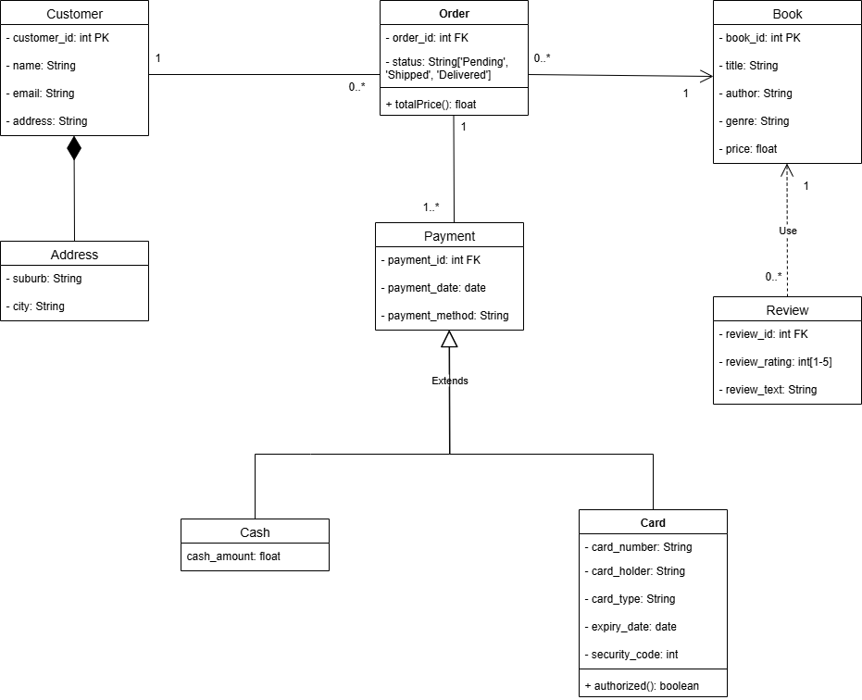

**REFERENCE LIST**

NoSQL Definition

Google Cloud, 2025. What is a NoSQL database? [Online] Available at:

< <https://cloud.google.com/discover/what-is-nosql> >

Motivation for choosing NoSQL

Meegle, 2025. Scaling NoSQL Databases [Online] Available at:

< <https://www.meegle.com/en_us/topics/nosql/scaling-nosql-databases>? >

DevBlog, 2025. Understanding NoSQL: Advantages and Real-World Use Cases [Online] Available at:

< <https://shiftasia.com/community/understanding-nosql-advantages-and-real-world-use-cases/> >

Types of data stored in NoSQL

DevBlog, 2025. Understanding NoSQL: Advantages and Real-World Use Cases [Online] Available at:

< <https://shiftasia.com/community/understanding-nosql-advantages-and-real-world-use-cases/> >

**GITHUB LINK**

[IIEWFL/isy6112-practical-assignment-st10446904-bophelothwala: isy6112-practical-assignment-st10446904-bophelothwala created by GitHub Classroom](https://github.com/IIEWFL/isy6112-practical-assignment-st10446904-bophelothwala)